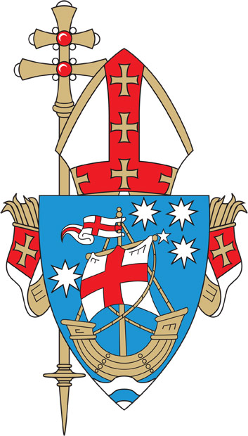

**CATHOLIC ARCHDIOCESE OF ADELAIDE**

Applications are called for the position of

**SACRAMENTAL COORDINATOR**

**Salisbury Catholic Parish**

**Part-time - 20 hours per week**

The Sacramental Coordinator will be responsible to the Parish Priest and will work collaboratively with him, and the Sacramental Management Team, in the administration and preparation of the Sacramental Program.

The Sacramental Management Team comprises the Parish Priest of Salisbury Catholic Parish and the Principals of Holy Family Catholic School and St. Augustine’s Parish School.

The successful applicant will have an active spiritual life, which is expressed through prayer, religious practice and commitment to living a Christian life according to the precepts, teachings and practices of the Catholic Church.

The Sacramental Coordinator willinitiate and facilitate a range of opportunities, forums, and resources to connect and engage parents in areas such as personal prayer, spiritual growth and the sacraments.

Excellent interpersonal skills are required, along with the capacity to develop, implement and evaluate programs.

Applications should be sent to Nicholas Dangcalan, Parish Business Manager, at businessmanager@salcath.org.au no later than the close of business (5.00 pm) on Monday, March 31, 2025. A copy of the Position Description can be obtained by emailing [recruitment@adelaide.catholic.org.au](mailto:recruitment@adelaide.catholic.org.au) or by phoning 82108291 or 82108292.

Employment with the Catholic Archdiocese of Adelaide is conditional upon a successful Working with Children Check and successful reference checks.

The Catholic Archdiocese of Adelaide is an Equal Opportunity Employer and a Child Safe Organisation.



**CATHOLIC ARCHDIOCESE OF ADELAIDE**

Applications are called for the position of

**SACRAMENTAL COORDINATOR**

**Salisbury Catholic Parish**

**Part-time - 20 hours per week**

The Sacramental Coordinator will be responsible to the Parish Priest and will work collaboratively with him, and the Sacramental Management Team, in the administration and preparation of the Sacramental Program.

The Sacramental Management Team comprises the Parish Priest of Salisbury Catholic Parish and the Principals of Holy Family Catholic School and St. Augustine’s Parish School.

The successful applicant will have an active spiritual life, which is expressed through prayer, religious practice and commitment to living a Christian life according to the precepts, teachings and practices of the Catholic Church.

The Sacramental Coordinator willinitiate and facilitate a range of opportunities, forums, and resources to connect and engage parents in areas such as personal prayer, spiritual growth and the sacraments.

Excellent interpersonal skills are required, along with the capacity to develop, implement and evaluate programs.

Applications should be sent to Nicholas Dangcalan, Parish Business Manager, at businessmanager@salcath.org.au no later than the close of business (5.00 pm) on Monday, March 31, 2025. A copy of the Position Description can be obtained by emailing [recruitment@adelaide.catholic.org.au](mailto:recruitment@adelaide.catholic.org.au) or by phoning 82108291 or 82108292.

Employment with the Catholic Archdiocese of Adelaide is conditional upon a successful Working with Children Check and successful reference checks.

The Catholic Archdiocese of Adelaide is an Equal Opportunity Employer and a Child Safe Organisation.

Expressions of interest should be sent to the Pastoral Director, Patricia Brady, at [pastoraldirector@ozemail.com.au](mailto:pastoraldirector@ozemail.com.au) no later than close of business (5.00pm) Friday, March 16, 2012. A copy of the Position Description can be obtained by emailing [adelaidehillsp@ozemail.com.au](mailto:adelaidehillsp@ozemail.com.au) or by phoning (08) 8339 1608.

Expressions of interest should address the selection criteria and include a Curriculum Vitae.

Employment with the Catholic Archdiocese of Adelaide is conditional upon a successful police clearance through the Catholic system and successful reference checks.

The Catholic Archdiocese of Adelaide is an Equal Opportunity Employer and a Child Safe organisation.